Client Application Form
Link-Up Victoria

Link-Up Victoria supports Stolen Generations and their families.
If you are Aboriginal or Torres Strait Islander, over 18 years of age, living in Victoria or Tasmania and have been separated from family, Community and Culture we can assist you to find and be reunited with your family, Culture and traditional Country.
For any questions or enquiries, please feel free to contact us at link.up@vacca.org or call us on (03) 9287 8800, or our free call number 1800 OUR MOB (1800 687 662).

Application Submission
There are two ways to submit your application to Link-Up Victoria, online or postal.
Online - Please email your documents to: link.up@vacca.org
Postal - Please return to: Link-Up Victoria, P.O. Box 191, Preston Vic 3072

About You
First/ Name: |  |  | Last Name:
Date of Birth: |  |  | Preferred Name:
Email: |  |  | Phone:
Home Address:
Gender Identity: | ☐ Female ☐ Male ☐ Non-binary ☐ Intersex ☐ Sistergirl ☐ Brotherboy
 | ☐ Transgender Female ☐ Transgender Male ☐ Prefer not to say
 | ☐ Self-Describe:
Pronouns: | ☐ She/Her ☐ He/Him ☐ They/Them ☐ Name Only ☐ Other (provide details below)
 | ☐ Self-Describe:
Sexual Identity: | ☐ Heterosexual/Straight ☐ Gay ☐ Lesbian ☐ Bisexual ☐ Asexual ☐ Queer  ☐ Unsure/Questioning ☐ Prefer not to say ☐ Other (provide details below)
 | ☐ Self-Describe:

Cultural Information
Cultural Identity: | ☐ Aboriginal |  |  | ☐ Torres Strait Islander | ☐ Both | ☐ Neither
Country of Birth:
Tribe/Mob: (if known)
Totem: (if known)
How did you find out about Link-Up?

History
I was: | ☐ Adopted ☐ Fostered ☐ State Ward ☐ Institutionalised ☐ Other
In what year, or how old were you when this happened?
Where were you placed?
Contact Person
Who else can we contact if we are unable to contact you?
First/ Name: |  | Last Name:
Email: |  | Phone:
Home Address:
Relationships to client:
on 2: Additional Contact Person
Support Person or Service
Do you have a support person working with you from another service? | ☐ Yes ☐ No
Name:
Email: |  | Phone:
Service/Organisation:

Your Request
Are you searching for information about yourself? |  |  | ☐ Yes ☐ No
Documentation: | Please note, you must provide a copy of your birth certificate with this application.  If you do not have your birth certificate, please contact Link-Up Victoria, as we can help you to obtain it.
Do you have your full birth certificate? |  |  | ☐ Yes ☐ No
Do you have your adoption or state ward file? |  |  | ☐ Yes ☐ No
Do you have any other information about your removal? |  |  | ☐ Yes ☐ No
Do you have a family tree? |  |  | ☐ Yes ☐ No
Do you have any other information about your family? |  |  | ☐ Yes ☐ No
If you answered yes, to any of the above, please provide copies of documents. If you do not have these documents, please contact Link-Up Victoria, any we will try to help you obtain them.
Any additional details can be provided below:
Are there any agencies or organisations assisting you with your search? If yes, please provide details.

Family Search
Are you searching for family? |  |  | ☐ Yes ☐ No
Who are you searching for? (e.g. mum, dad, brother, sister)?
First given name:
Second given name:
Surname:
Date of birth:
Place of birth:
State
Cultural Identity | ☐ Aboriginal ☐ Torres Strait Islander ☐ Both ☐ Neither
Do you have any documents about this person? |  |  | ☐ Yes ☐ No
What year was this person separated from the family?
Where were they placed?
Are you searching for additional family, other than the person specified above? |  |  |  |  |  |  | ☐ Yes ☐ No
If yes, please provide details:
*If you have any documents regarding this person, please provide copies of documents. If you do not have these documents, please contact Link-Up Victoria, any we will try to help you obtain them.

Family Information

Mother’s Information:
First/ Name: |  | Last Name:
Other Name/Alias: |  | Last Name:
Date of birth:
Place of birth:
State of birth:
Mother’s cultural identity: |  | ☐ Aboriginal ☐ Torres Strait Islander ☐ Both ☐ Neither

Father’s Information:
First/ Name: |  | Last Name:
Other Name/Alias: |  | Last Name:
Date of birth:
Place of birth:
State of birth:
Father’s cultural identity: |  | ☐ Aboriginal ☐ Torres Strait Islander ☐ Both ☐ Neither

How can we help?
- How would you like Link-Up Victoria to assist you?
Please provide as much information as you can and use an extra piece of paper if you need to

- If you are searching for a family member (or family members), please provide as much information as you can about who you are searching for, e.g. birth dates, places (where born, where taken from, where taken to), parents’ names, brothers and sisters, cousins, uncles, aunties, any information that will help us find them.

Your Identification
Documentation Provided: | You need to provide copies of three kinds of current personal identification with this form, stating your current address and preferably including a photo and/or signature. Tick the forms of ID you have attached.  Please note, you must provide a copy of your birth certificate with this application. If you do not have your birth certificate, please contact Link-Up Victoria, as we can assist.

☐ | Birth Certificate
☐ | Driver Licence
☐ | Health Care Card
☐ | Pension Card
☐ | Medicare card
☐ | Key Pass
☐ | Bank Card (eftpos, key card, credit card)
☐ | Student Card
☐ | Other ID – please specify

Permission for Link-Up Victoria
Would you like to be included on the Link-Up Victoria mailing list? | ☐ Yes ☐ No
Do you consent to your photograph being used for promotional purposes (e.g. newsletter, website, etc.)? | ☐ Yes ☐ No
The “Link-Up National Name Index” improves family tracing services through interstate Link-Up services. Do you consent to your name, date of birth and place of birth being registered on this database? | ☐ Yes ☐ No
If we need to refer you to another service specific to your needs, do you consent to Link-Up Victoria sharing your personal details with other services, agencies and organisations? | ☐ Yes ☐ No
Link-Up Victoria seeks to continually improve the service we provide to our clients. One of the ways we do this is to organise an independent review of our service. Do you consent to your file being included in our reviews? | ☐ Yes ☐ No
If there are any places that you do not want your information shared with, please provide details below.

Consent
☐ | I confirm that I have read and understand the Link-Up Victoria Client Rights and Responsibilities booklet, which explains my rights and responsibilities as a client. I also confirm that I have received an information pack describing the services offered by Link-Up Victoria, along with details about privacy and the use of my personal information.
Full name:
Signature:
Date:

*For any questions or enquiries, please feel free to contact us at link.up@vacca.org or call us on (03) 9287 8800, or our free call number 1800 OUR MOB (1800 687 662).

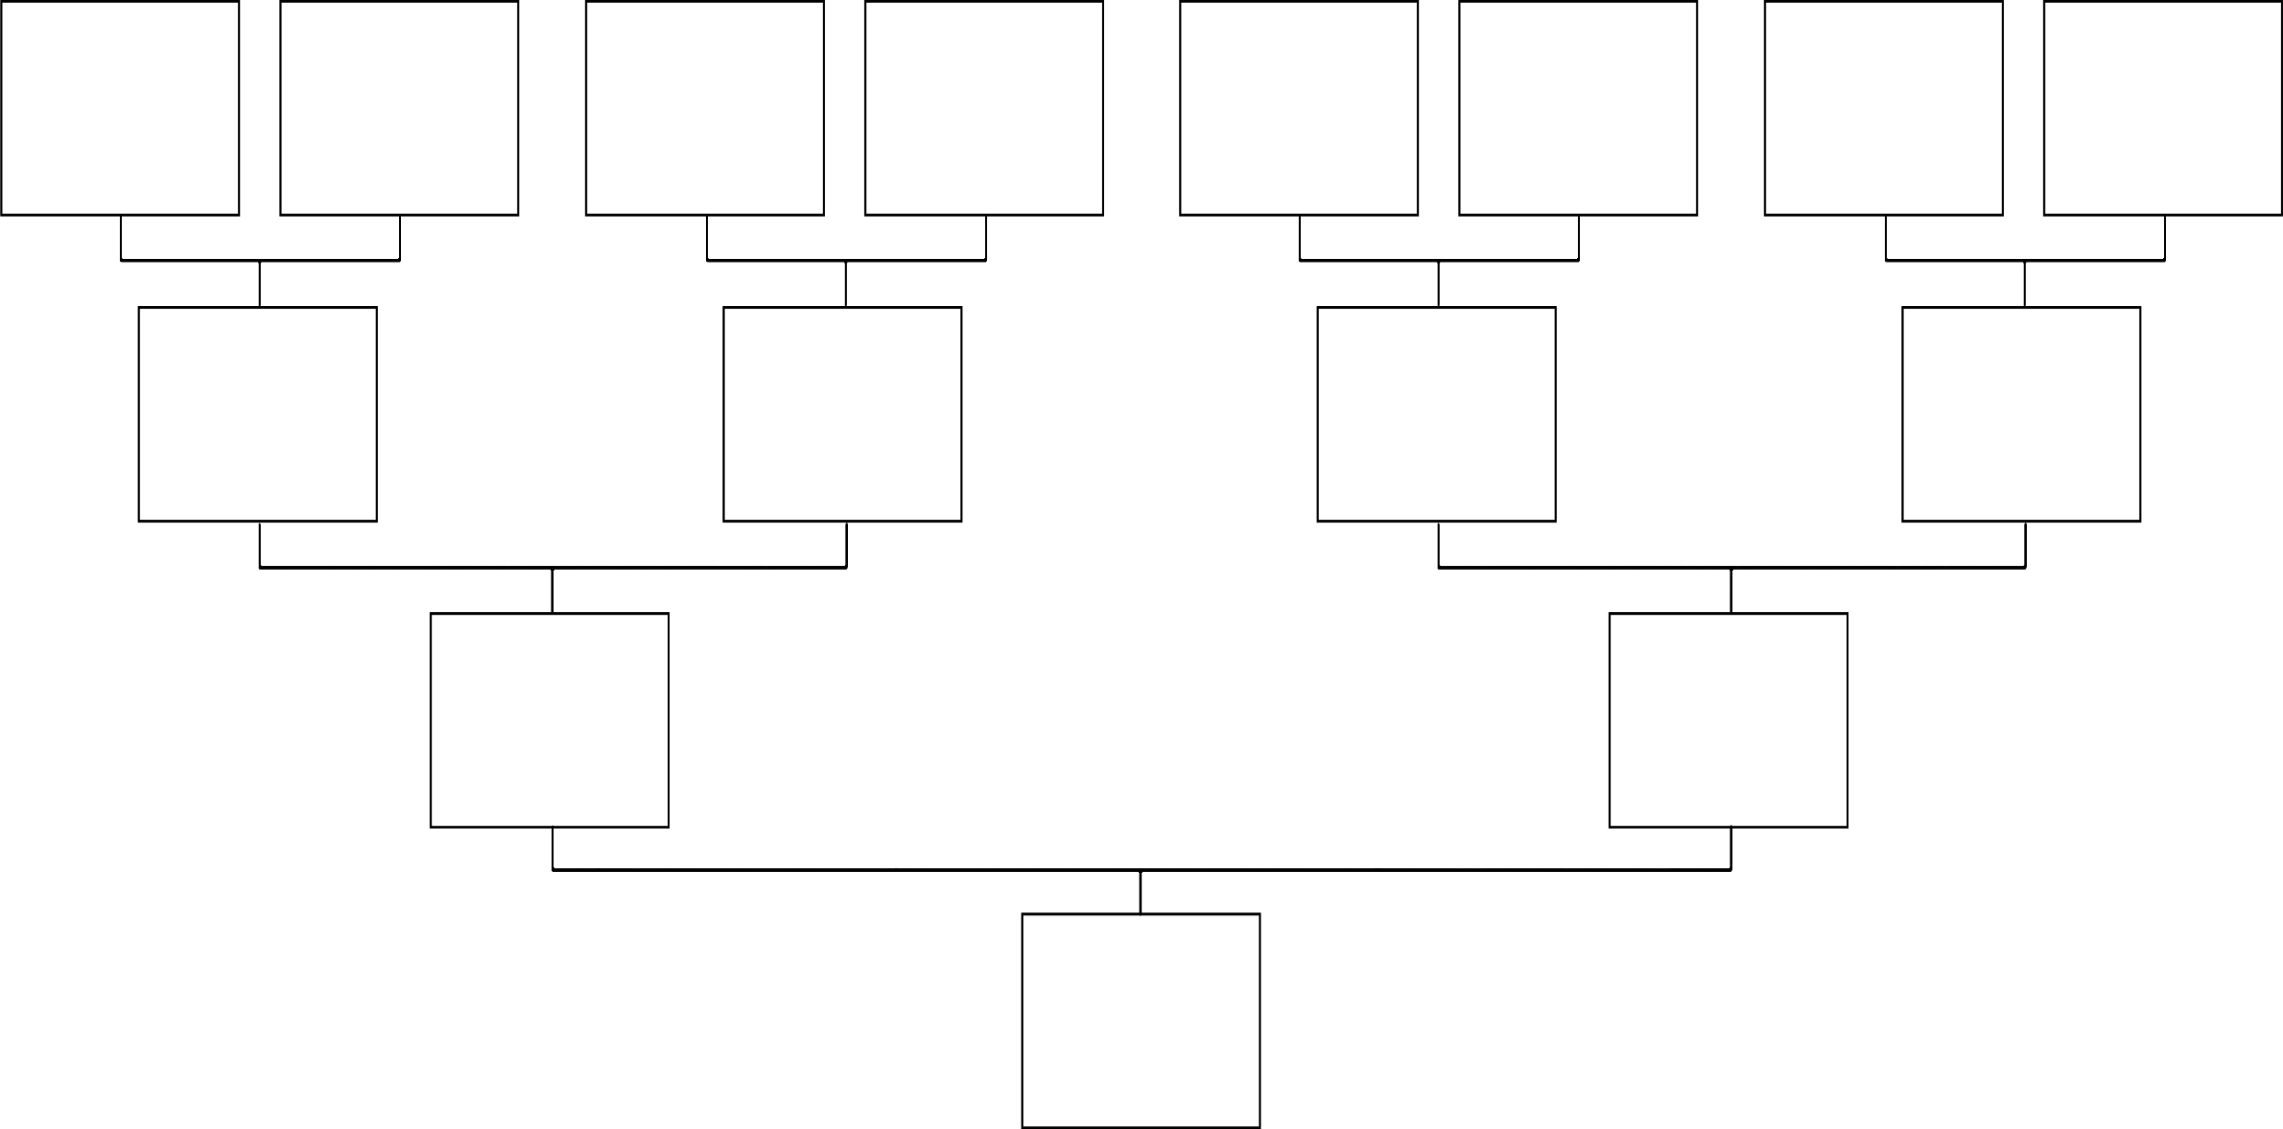
Family Tree
Please share whatever you know about your family connections in the below family tree. If some of this information is unknown to you, that's completely okay — just fill in what you can. If possible, please include full names, dates of birth and dates of death. This information will help Link-Up workers find your family, mobs and connections.

